

FOR IMMEDIATE RELEASE

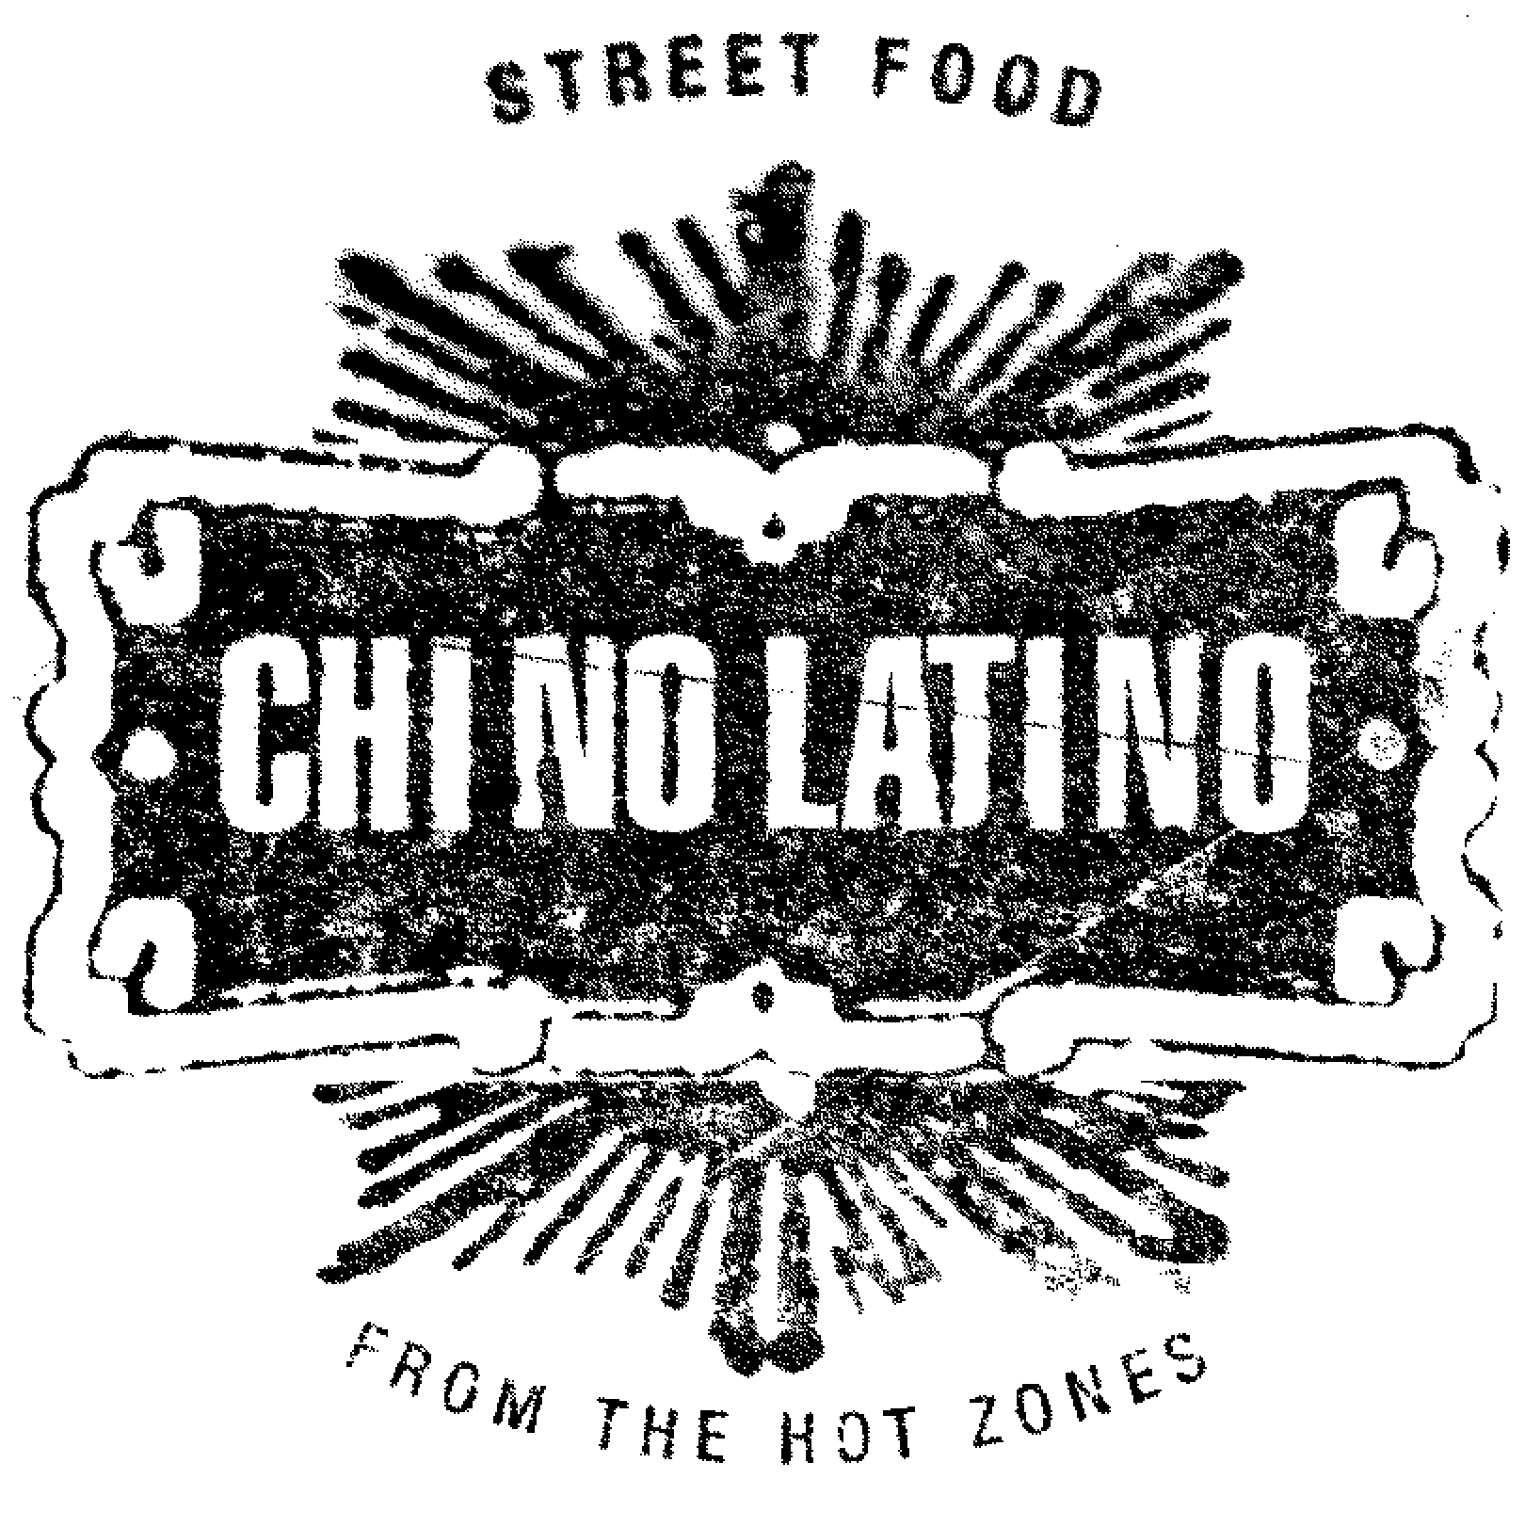

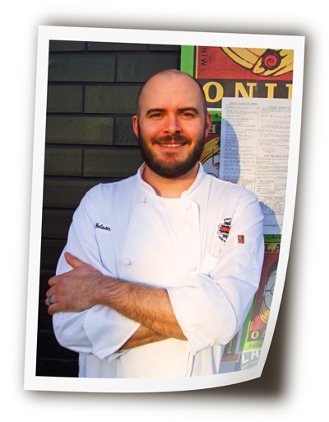
CHINO LATINO’s Tyge Nelson waxes on his restaurant – and shows off his Brazilian

Minneapolis, Minn., March 7, 2012 – Chefs can’t help it. They’re culinary exhibitionists. Newly appointed CHINO LATINO Executive Chef Tyge Nelson is no different. These days he’s flashing his Brazilian all over the street -- the STREET SHEET, at any rate.

Currently on the STREET SHEET: BRAZIL

“Every day, we supplement our regular menu with the STREET SHEET’s focus on a particular Hot Zone,” says Tyge. “The spotlight remains fixed for the entire quarter, but the roster of daily offerings can change at any time based on the availability of ingredients, guest preferences, and our changing inspirations,” says Tyge.

Right now, the focus is on Brazil, and today’s offerings include:

CRISPY SHRIMP & COD CROQUETTAS
with Key Lime/green chile aioli, over a salad of freshly chopped olives and pimiento. $10

TAMARIND-GLAZED SUGAR CANE SHRIMP
Served on a salad of oranges, red onions, and hearts of palm. Topped with avocado. $12

BRAZILIAN FEIJOADA
Traditional Brazilian black bean stew served with sausage, pork and braised greens, garnished with a spicy orange salad. $26

GALHINA COPACABANA
Whole roasted chicken with Brazilian mustard sauce, accompanied by traditional sides of plantain farofa, braised greens and crispy fried banana. $32

“In some ways, Brazil is the ultimate CHINO-LATINO destination,” says Tyge. “Start with the collision of native Indian and Portuguese influences about 400 years ago. Then add the culinary contributions of the millions of African slaves. Mix in centuries of immigration from Europe and the Middle East. And don’t forget to include all the Asian immigrants over the last several decades.

“Brazil is a melting pot you can dip into forever without getting bored.”

What about future STREET SHEETS?

“Recently the STREET SHEET covered the Caribbean and Vietnam, but everything else is open for exploration,” says Tyge.

“In and around the Americas, I’d love to concentrate on Mexico, Ecuador and Argentina, as well as Peru; its cuisine is very hot at the moment. Then again, I wouldn’t mind lingering around the islands a while longer, particularly Cuba or Jamaica. But China beckons, too, and I’m fascinated by Korea. It’s a very meaty destination, in every sense of the word.”

In informal polls of CHINO LATINO guests, Thailand probably comes up more often than any other destination, explains Tyge. “People love their Pad Thai and curries, and they’re hungry to go deeper.”

Tyge Nelson: A world-class talent…

“We scored a major coup in landing Tyge for CHINO LATINO,” says Parasole’s head of culinary development, Tim McKee. “He’s a formidably talented chef. I know because we’ve worked together for years.”

Tyge first met Tim in the year 2000, when he began work at McKee’s acclaimed La Belle Vie restaurant. There Tyge displayed both a keen culinary sensibility and strong operational and managerial skills. “Tyge helped us move the restaurant from Stillwater to Minneapolis without skipping a beat.”

So impressed was McKee that he promoted Tyge to the position of Executive Chef at Solera restaurant. Next, he became Executive Chef of Barrio Tequila Bar in St. Paul, and then The Inn, in downtown Minneapolis.

…with a global focus.

“I’ve been really fortunate to work in dramatically different genres,” says Tyge. “From the haute Provencal style of La Belle Vie to the vast palette of flavors we played with at Solera, to the lustiness of Barrio, every day has been an adventure.

“But CHINO takes creative opportunities to a whole new realm. There are so many cultures to explore. We have adventurous guests who’ll go there with me. And Parasole offers chefs all the freedom we need.”

One thing Tyge particularly likes about CHINO LATINO: Its focus on authenticity. “With a name like ours, you might expect us to be a fusion restaurant, but we don’t mix distinct cuisines, we juxtapose them. I’m not interested in doing Moo shu pork burritos; I want to dive deep into both Chinese AND Mexican cooking – and a dozen other cuisines for that matter – and see where the path leads.”

About Parasole

Headquartered in Minneapolis, Minnesota, Parasole Restaurant Holdings operates Chino Latino and Uptown Cafeteria & Support Group (along with Sky Bar on the roof) at Hennepin & Lake; Manny’s Steakhouse, The Living Room & Prohibition at the W Minneapolis – The Foshay; Pittsburgh Blue Steakhouse in Maple Grove and Edina; Salut Bar Amèricain in Edina and St. Paul; Muffuletta Café in St. Paul; Burger Jones in Burnsville and Uptown; the Good Earth Restaurants in Edina and Roseville; and Mozza Mia Pizza Pie & Mozzarella Bar in downtown Edina.

By joining the Parasole Dining Club, guests have the opportunity to earn points for the dollars they spend and to redeem them for food and drink at any participating Parasole restaurant. Details at Parasole.com.

Company Contact:
Kip Clayton
Vice President of Marketing
Parasole Restaurant Holdings
Office (612)822.0016
Fax (612)822.0705
Cell (651)341.8009
kclayton@parasole.com

